Maintenance Manager
Release Notes v4.3.0.0

Contents
1 Document Control 3
1.1 Author 3
1.2 Document Summary 3
1.3 Document History 3
1.4 Reference documents 3
1.5 Distribution 3
1.1 Quality Assurance 3
2 Introduction 4
2.1 Pre-Requisites 4
3 Functional Changes 5
3.1 Inspection Loader (Enhanced) 5
3.2 Inspection Loader – Error Correction (New) 7
3.3 Inspection Loader – Defect Superseding (Enhanced) 8
3.4 Automated Work Order Creation (New) 9
3.5 Defects and Inspections 10
New Defect Status Code 10
Defect Status Code - Reason for Change 10
Defect Date Recorded 10
Navigator Button 10
Create Work Order Button 10
3.6 Works Orders 12
Work Order Derived Status Code 12
Navigator Button 12
New Work Order Line Status Code 12
Work Order Flexible Attributes 13
3.7 CIM Extract and Load (Enhanced) 13
3.8 Roles 14
3.9 Product Option CIMALLEST 14
3.10 Product Option WORREFUSER 15
3.11 Product Option DEFDOCLOCN 15
3.12 Product Option DEFDOCTYPE 16
4 Log No. Summary 17

- Document Control
  - Author
Exor Development

  - Document Summary
This document provides information about functional changes and a list of all logs fixed in this release.

  - Document History

Document History
Revision | Date | By | Description
1.0 | 30-SEP-2010 | Exor Development | First Edition

  - Reference documents
None

  - Distribution
Exor Customers, Partners and Staff

  - Quality Assurance
Document Details
File | Prepared By
Maintenance Manager at v4.3.0.0 | Exor Development
Document Name | Reviewed By
Maintenance Manager at v4.3.0.0 | Mark Lowe
Version | Approved for issue by
1.0 | Colin Stewart
Date of Issue | Support Manager
30-NOV-2010 | Graham Anns

- Introduction
This document defines the changes made to the Maintenance Manager product at release v4.3.0.0 plus a list of all logs fixed in this release.

Unlike the “Maintenance Manager Installation/Upgrade Guide”, this document is specifically targeted at the Maintenance Manager end user. Therefore, if the recipient of this document is an IT person please ensure that it is forwarded on to the relevant end user(s).

This document does not comprehensively describe the functionality of the product, or act as a User Guide.

Please note that any data shown in example screenshots does not represent any Customer’s live data; it is test data set up by Exor.

After reading through this document, should you have any further Maintenance Manager training or Consultancy requirements then please contact your Exor account manager.

  - Pre-Requisites

No pre-requisites at this release

- Functional Changes
This section outlines the function changes made at v4.3.0.0
  - Inspection Loader (Enhanced)
The Maintenance Manager Inspection Loader has been replaced with a single stage loading process that can be run manually or fully automated using the Process Automation Framework.
When fully automated, inspection files can be dropped in a specified ftp directory where they are automatically loaded with no user intervention needed.

Other changes to the inspection loader are:-
- The Exor listeners are no longer required for this process
- The loader is now a single stage loader, i.e. there is no longer a Stage 1 and Stage 2 process
- Defect superseding now has configurable rules based on Admin Unit/Initiation Type combination
- New screen to view the outcome (success or fail) of the load
- New module to correct inspection load errors
- Alert Manager can be used to email nominated users if a load has failed
If automatic work order creation business rules have been configured, new work orders may also be created as a result of new defects being loaded.

Please refer to the Maintenance Manager User Guide for further information.

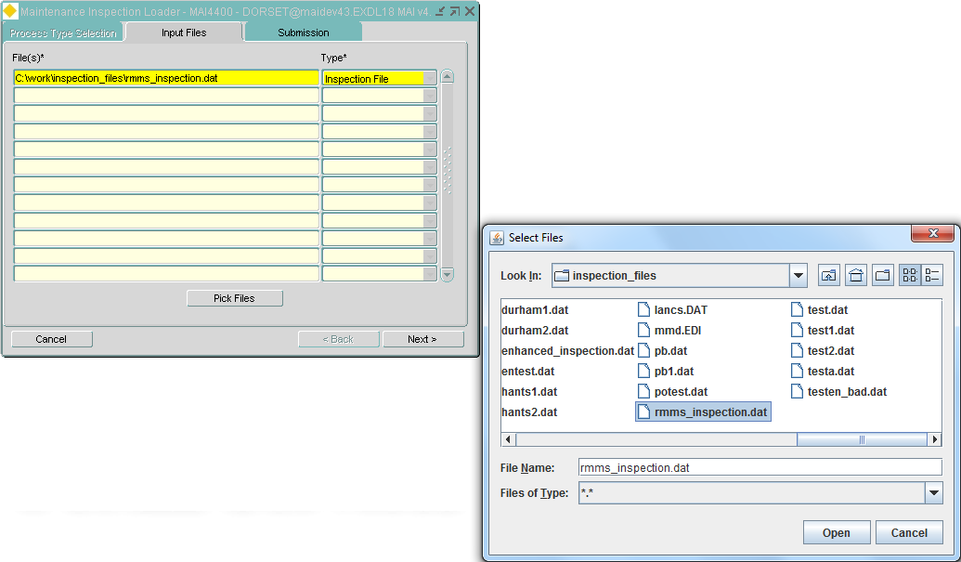
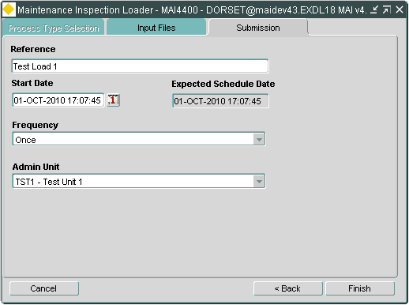

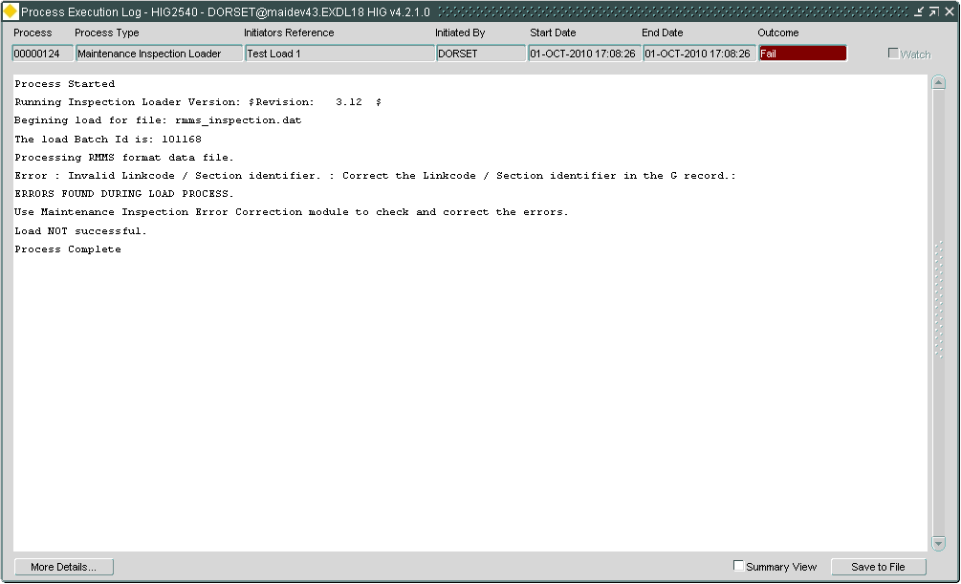

  - Inspection Loader – Error Correction (New)
The Maintenance Manager Inspection Loader – Error Correction module has also been replaced and where possible displays the inspection load errors in a more user friendly manner. This now shows invalid files and invalid inspections in separate tabs. The ‘Invalid Inspection’ tab shows the hierarchy within the inspection batch of the Inspection/Defect/Repair items, the invalid item is shown with the icon against the appropriate record. Each item within the hierarchy has its own maintenance screen giving the user the ability to make the changes to the file and re-submit once the changes have been made.
An example of an invalid inspection is shown below:

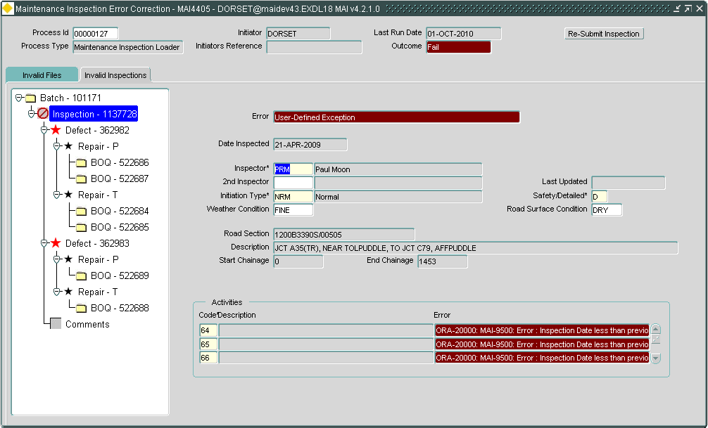
If the loader is unable to validate the file structure then the errors will be presented in the Invalid Files tab which is similar to the old error correction screen.
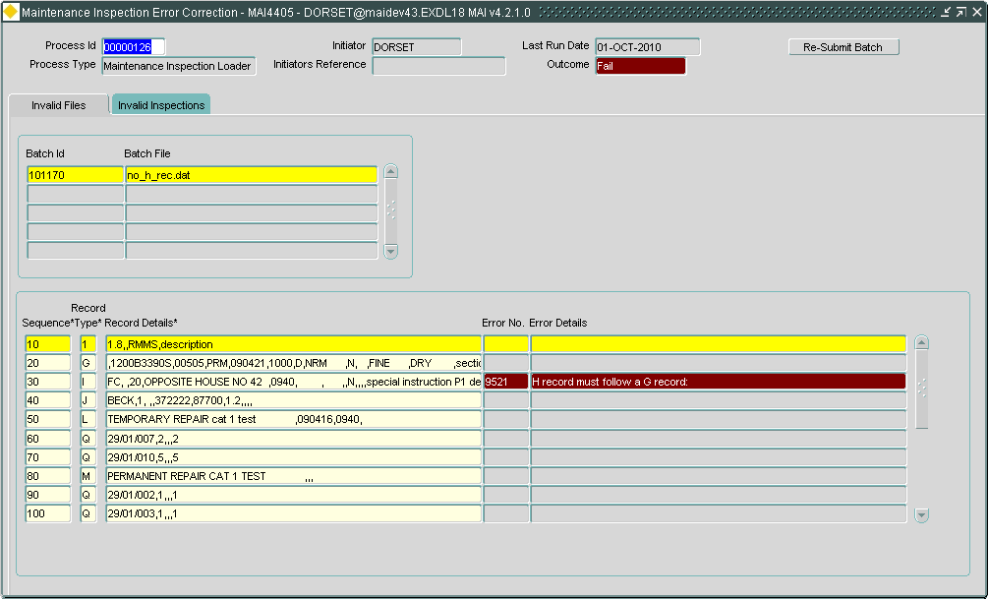

Please refer to the Maintenance Manager User Guide for further information.
  - Inspection Loader – Defect Superseding (Enhanced)
The Defect Superseding Rules module has been introduced to allow greater control over the superseding logic applied by the Maintenance Inspection Loader.

A rule for each combination of Admin Unit and Initiation Type can be created, specifying a tolerance to be used when matching Defects.

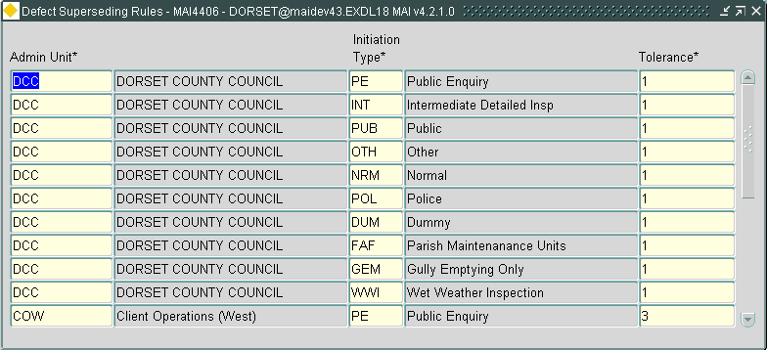

When an inspection is loaded the system will check for the existence of a superseding rule (and therefore a tolerance). The Admin Unit of the Maintenance Section upon which the Defect is located will be checked. If a rule exists for this Admin Unit it will be applied. If no rule exists the system will work its way up the Admin Unit hierarchy until it either finds a rule or it runs out of Admin Units to check.
i.e. If a rule exists for several Admin Units in the hierarchy the tolerance of the lowest Admin Unit will be used.
For example:-
Admin Unit | Initiation Type | Tolerance
TOP | NRM | 8
LEV2 | NRM | 5

Where the top level Admin Unit is TOP and the second level Admin Unit is LEV2.
In this example, any defects found on sections belonging to LEV2 Admin Unit will use a tolerance of 5 when matching. All others will use a tolerance of 8.

In summary Superseding will occur if:-
- The Inspection is loaded via the Maintenance Inspection Loader.
- The Product Option USEDEFCHNL or USEDEFCHND (depending on the sys_flag of the maintenance section) is set to Y.
- A Rule for the Initiation Type of the Inspection exists for the Admin Unit of the Maintenance Section or an Admin Unit higher up the hierarchy.

Please refer to the Maintenance Manager User Guide for further information.

NB. When 4300 is applied as an upgrade if the system has been configured to run the Superseding logic, when loading an Inspection, a set of default rules will be created that configure Superseding to work to the same parameters that applied before the upgrade.
  - Automated Work Order Creation (New)
The new Automated Work Order Creation module allows for the definition of rule sets that will be used to determine whether the system should automatically create (and optionally instruct) Works Orders when Defects are loaded or created within the system.

Alert Manager can be used in conjunction with this module to alert appropriate users to the creation of new work orders if required.
Please refer to the Maintenance Manager User Guide for further information.
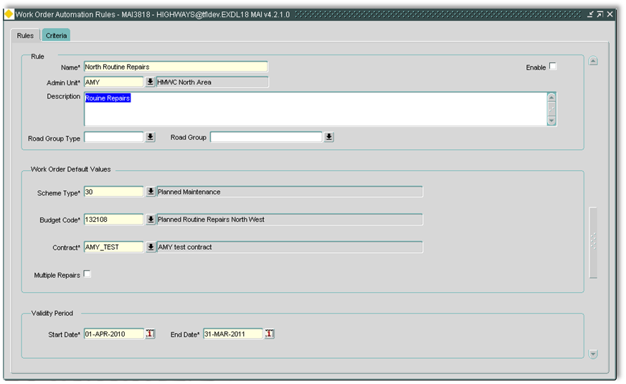
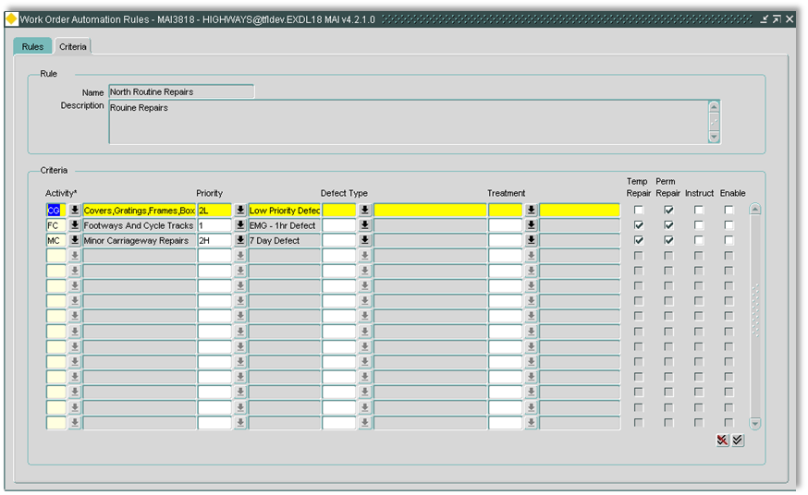

  - Defects and Inspections
New Defect Status Code

A new defect status code of ‘Selected’ has been added. This new status code is linked to the work ordering process and is the status code to which the defect is set when it is placed on an un-instructed work order.
Once the work order is instructed the defect status code will automatically change to ‘Instructed’ and proceed through its lifecycle as it does currently.

Defect Status Code - Reason for Change

When a defect status code is updated manually, or the defect is completed by entering a Repair Completion date, via the Inspection form (MAI3808), the user will be prompted for a reason for the status code change. When the defect is being automatically updated by the system no reason will be recorded. Audit Manager can be used to provide a history of Reasons.

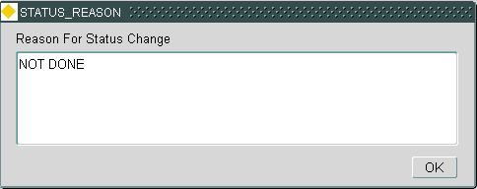

Defect Date Recorded

The date and time the defect was loaded into the system will be recorded.

Navigator Button

A new button has been added to the Works Order form (MAI3800) that allows the user to call Navigator

Create Work Order Button

A new Raise Work Order button had been added to both the Defects (MAI3806) and Inspections (MAI3808) forms to allow the user to raise a work order when reviewing the defect details. This button will call the standard raise work order wizard that is used when raising a work order in Locator.

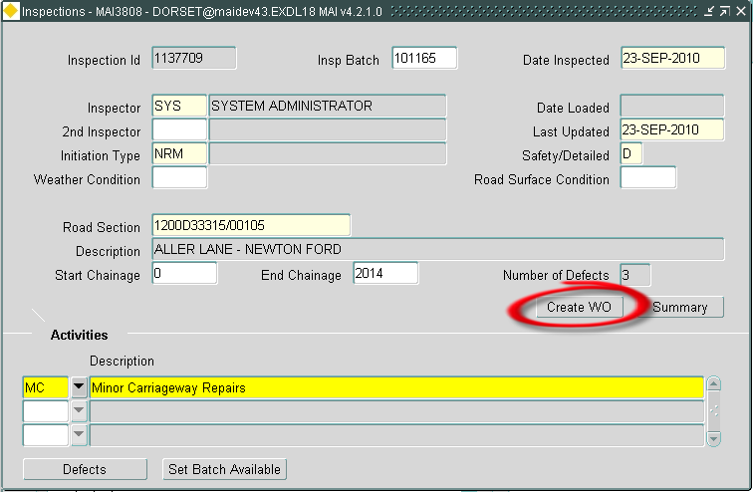
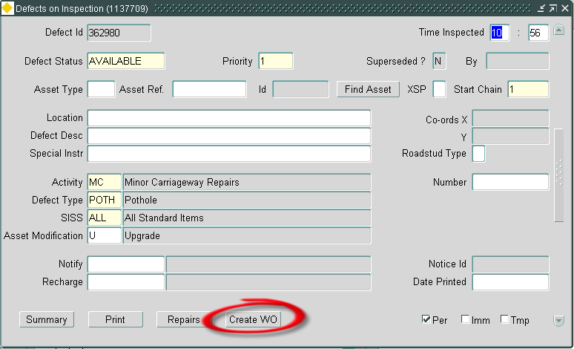

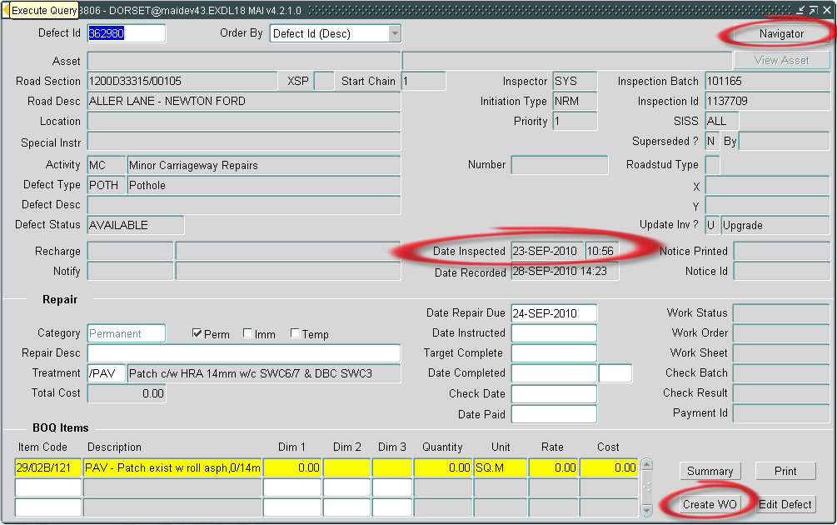
  - Works Orders
Work Order Derived Status Code

A new status code has been added to the work order. This status code is derived from the various status codes of the work order lines on the work order and indicates the overall status of the work order.

Navigator Button

A new button has been added to the Works Order form (MAI3800) that allows the user to call Navigator

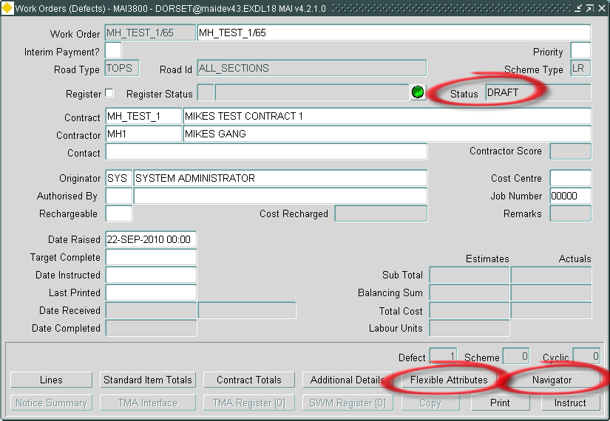

New Work Order Line Status Code

A new work order line status code of ‘Draft’ has been added. This is the status of all work order lines (defect clearance, small schemes and cyclic) prior to the work order being instructed. Once the work order has been ‘Instructed’ and saved, the work order line status code will become ‘Instructed’ and will proceed through its life cycle as it does currently. Any new work order lines added to a work order that is instructed will have the status of ‘Instructed’.
For defect clearance work orders the status of the actual defect will be ‘Selected’ until the work order is instructed at which point it will have a status of ‘Instructed’.

Work Order Flexible Attributes

A new facility allowing customers to define a set of flexible attributes for a work order based on the scheme type. This allows the customer to define a set of attributes that are specific for Small Scheme work orders and another set of attributes that are specific for cyclic work orders. The characteristics of these new attributes may be date, number, integer, character or a list of values.

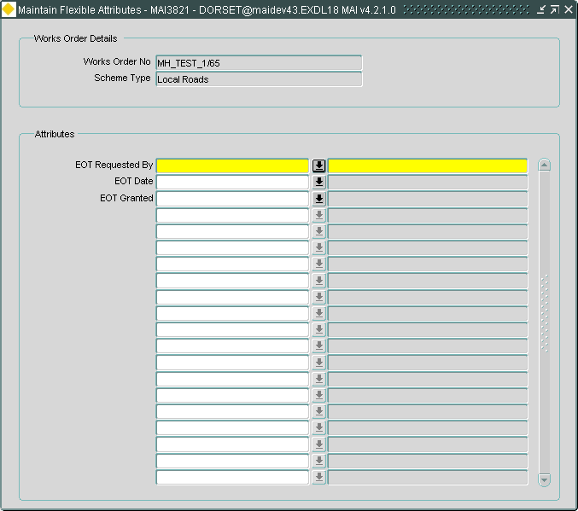

  - CIM Extract and Load (Enhanced)
Users of CIM now have the option to use the Automated Process Framework to carry out the following:
- Create the work order file extract
- Load the completions file
- Load the invoice file

The work order file extract will be automatically executed at pre-defined intervals and the extract file placed in an FTP directory that each contractor will have access to.
The location of the completions and invoice files are polled at pre-defined intervals and any files found will be automatically loaded allowing the user to use the Invoice Verification and Payment Approvals modules as usual. An alert will be sent to a specified user, highlighting any errors found whilst loading the files. The invoice verification form can be used to manage these errors as usual.
Please refer to the Maintenance Manager User Guide for further information.

  - Roles

The following table shows the default Roles attributed to new Modules in this release.

Module | Default Roles
Maintenance Inspection Loader (MAI4400) | MAI_ADMIN, MAI_USER
Maintenance Inspection Error Correction (MAI4405) | MAI_ADMIN, MAI_USER
Application Attributes (MAI3819) | MAI_ADMIN
Maintain Flexible Attributes (MAI3821) | MAI_USER
Work Order Automation Rules (MAI3818) | MAI_ADMIN
Defect Superseding Rules (MAI4406) | MAI_ADMIN, MAI_USER

  - Product Option CIMALLEST
When set to 'Y' this Product Option will ensure that only estimated costs are included in the CIM interface WO file.

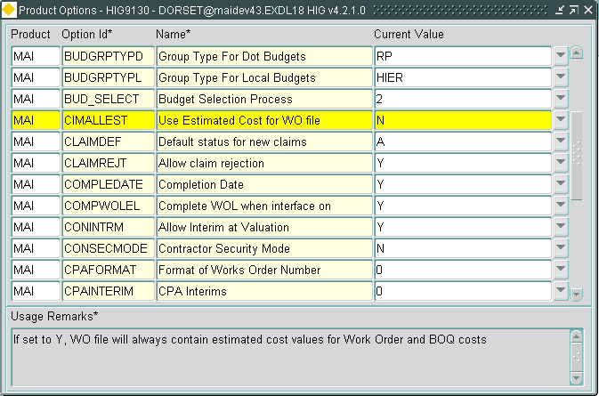

This product option has two values,

N = Export Actual Costs once they have been entered; this is how previous versions have worked and is the default value.

Y = Only export Estimated Costs.
  - Product Option WORREFUSER
When the product option WORREFGEN is set to ''A'' (Admin Unit) this option can be set to ''Y'' to force the generation of Work Order Numbers to always use the Users Admin Unit rather than the Admin Unit of the selected Contract.

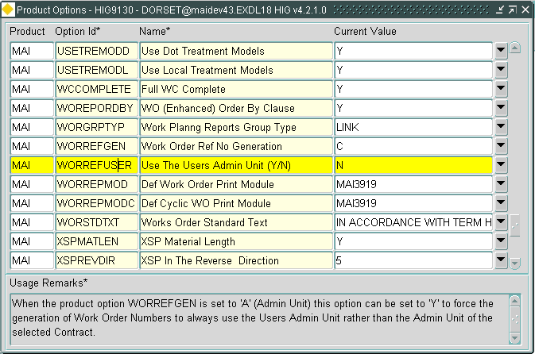

This product option has two values,

N = Contract Admin Unit is used for Works Order Numbers, this is the default value.

Y = Users Admin Unit is used for Works Order Numbers.
  - Product Option DEFDOCLOCN
This product option should be used to define the default Document Location for Defect document attachments loaded via the Maintenance Inspection Loader.

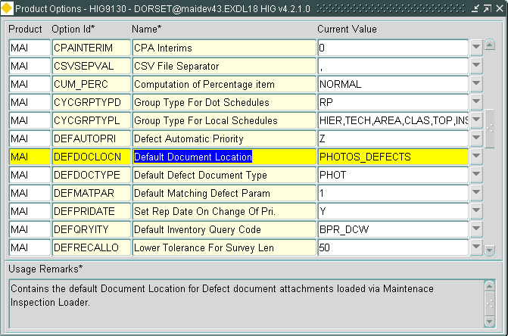

This product option can be populated with any valid Document Location (DOC0118).
  - Product Option DEFDOCTYPE
This product option should be used to define the default Document Type Code for Defect document attachments loaded via the Maintenance Inspection Loader.

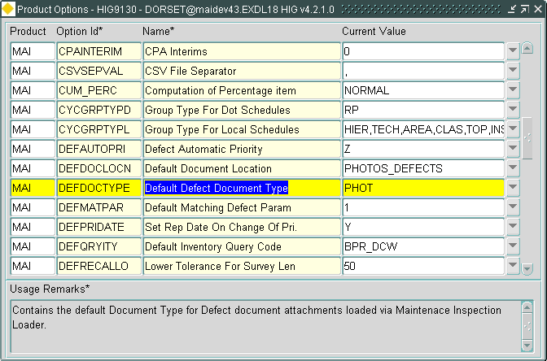

This product option can be populated with any valid Document Type (DOC0110).

- Log No. Summary
This chapter summarises all Software Changes (enhancements and new functionality) and Bug Fixes that have been made in this release.

These changes are derived from the following sources,

- Issues raised by Customers via Exor Support
- Issues raised internally by Exor

Internal  Task ID | Issue | Support  Log(s)
0107284 | The "Create Defect From Locator" form (MAI3807) has been changed to validate the quantity entered on a BOQ against the Min and Max Quantity values of the associated Standard Item. | 708746
0107332 | Fixed an issue in the calculation of Amount To Pay for Interim Claims during the Payment Run when Discount Groups are in use and the current Interim Claim takes the value of the Works Order into a new Discount Band. | 714467
0107346 | The generation of the PED file has been changed to display the name of the file created in the Spooled Output. | 716965
0107374 | Inspection Loader - When an invalid Activity was encountered on the H record the old Inspection Loader raised a misleading error message referring to the Defect Time. The old inspection Loader has been replaced (see the New Functionality section of this document) and the new Loader has been coded to raise a more informative error message. | 715215
0107416 | When loading Invoice Files (MAI3852) the processing of Interim Claims was not updating the Budgets correctly. | 717190  725121
0107900 | The main query in the report "Summary of Defects Not Yet Instructed" (MAI3920) has been modified to improve the performance.
0108076 | A review of the flexible attribute columns that can be assigned to a Defect Type has been performed and the following changes have been made to the size of data that can be stored in these columns:-  DEF_AREA from NUMBER(8,1) to NUMBER  DEF_COORD_FLAG from VARCHAR2(1) to VARCHAR2(240)  DEF_DIAGRAM_NO from VARCHAR2(7) to VARCHAR2(240)  DEF_HEIGHT from NUMBER(6,1) to NUMBER  DEF_IDENT_CODE from VARCHAR2(8) to VARCHAR2(240)  DEF_LENGTH from NUMBER(6,1) to NUMBER  DEF_NUMBER from NUMBER(5,1) to NUMBER  DEF_PER_CENT from NUMBER(5,1) to NUMBER  DEF_SERIAL_NO from VARCHAR2(6) to VARCHAR2(240)  DEF_SKID_COEFF from NUMBER(4,1) to NUMBER | 711639  710506  710404
0108110 | A change has been made so that updates to a Works Order that is associated with a PEM (via a Defect) will only update the PEM Status when the PEM has not been completed. | 721398
0108594 | Problem when calculating quantities in the "Cyclic Maintenance Schedules" form (MAI3860).  An error message ('hig1069 database constraint violated schr_index_p1') was being displayed when the "Schedule By Asset" flag is set to 'Y'.  A change has been made to the index schr_index_p1 to resolve this problem. | 727184
0108872 | The existence of AVAILABLE Defects no longer prevents the closure of a Section.  If AVAILABLE Defects exist on the Section being closed they are marked as "Not Refound" in such a way that they can be restored to their previous state should the Section be re-opened.
0108904 | Works Orders (MAI3800) - A Time element has been added to the Date Raised to allow for accurate calculation of the Target Date when Works Order Priorities and Intervals are in use. | 723919
0108980 | A new Inspection Loader has been written to provide single step manual loading of inspection files or automation through the new Process Management framework.
0109080 | New Product Option CIMALLEST which, when set to 'Y', will ensure only estimated costs are included in the CIM interface WO file. | 723588  727889  726867
0109182 | The CIM interface can now be automated through the new Process Management Framework.
0109183 | New functionality has been added to allow the automatic generation of Defect Works Orders. See the New Functionality section for further details.
0109185 | A review of the MAI IMF views has been carried out and various changes made.
0109186 | Works Order Status:  A new Works Order Status has been added to the Work Order form (MAI3800), this status is derived from the Status of all the associated Works Order Lines.  Works Order Line Status :  A new Status Code, DRAFT, has been introduced, this will be the initial status of a new Works Order Line on an un-instructed Works Order.  When the Work Order is instructed the status of all associated Work Order Lines is updated to INSTRUCTED.  Both the DRAFT and INSTRUCTED Status Codes have the same functional effect that INSTRUCTED currently has within the system.  Defect Status :  A new Defect Status Code, SELECTED, has been introduced as the Status of a Defect with 1 or more Repairs associated with a DRAFT Works Order Line. When the associated Works Order Line Status is updated to the INSTRUCTED the Defect status will also be updated to INSTRUCTED.  Both the SELECTED and INSTRUCTED Defect Status Codes have the same functional effect that INSTRUCTED currently has within the system.
0109271 | New functionality to allow flexible attribution on Work Orders has been introduced.  See the New Functionality section for further details.
0109272 | Buttons have been added to the Inspections form (MAI3808) to allow the user to add the defect(s) to a Works Order.
0109275 | A new column has been added to the Defects table to allow the system to store both the date the defect was observed (i.e. the date of the inspection) and the date the Defect was created within the system (either entered through the application or loaded from a file).
0109278 | When manually changing the Status of a Defect in the Inspections form (mai3808) the User will be asked to enter a reason for the change. The most recent reason given is stored in the defects table. If a history of reasons given is required an audit should be setup using Audit Manager.
0109286 | The Defect Superseding logic used by the inspection loader has been enhanced to allow it to be enabled for a specified list of Admin Units and Inspection Initiation Type.  The tolerance to be used when matching Defects by chainage can be individually specified for each Admin Unit / Initiation Type in the list.  See the New Functionality section for further details.
0109295 | In the Contractor Interface (CIM), when loading a Completion File(WC), only the completion date is updated the time element is ignored.  Changes have been made to ensure that the time element is included in the update. | 725264
0109307 | View Cyclic Maintenance Work (MAI3804), the BOQ Description has been expanded to 254 Characters to avoid truncation errors. | 725361
0109308 | Inspections form (MAI3808) - The Road Section field has been expanded to allow the full 30 characters allowed for the Unique reference. | 725159
0109351 | Parameter 'End Dated Sections (Y/N)' has been added to the Print Inspections Report (MAI3900) parameter list, allowing for the reporting of Inspection Details for End Dated sections | 725423
0109482 | Changed to allow Cancelation of Works Orders when the Budget is blown. | 725472
0109483 | Changes to the processing of CIM WI files to ensure that the invoices being processed are rejected if they take the associated Budget over its limit. | 725472
0109514 | Create Defect From Locator form (MAI3807) - The Initiation Type LOV is now ordered by the sequence number held against the Domain Codes. | 725996
0109531 | Work Orders Authorisation form (MAI3848) - Corrected the formatting of the Total Cost field. | 726031
0109574 | Repairs on Works Order Lines at the Status of "NOT DONE" are now available for selection onto new Works Order Lines. | 725919
0109607 | PEM Status was not being updated when an associated Defect is cancelled on a Works Order.  A change has been made so that the PEM Status will return to DR (Defect Raised) when the Works Order is cancelled. | 726185
0109632 | Once a Works Order has been Instructed the Authorised By and Date Instructed fields cannot be nullified, i.e. the Works Order cannot be un-instructed.
0109665 | The C modules (mai2200d and mai2200c) previously used to load Inspection data have been replaced by a single module running under the new Process Management Framework. See the New Functionality section of this document or the MAI User Guide for further details of the new Inspection Loader.
0109688 | The generation of the PED file has been changed to exclude end dated data. | 726452
0109689 | In Contractor Interface zero value were assigned to BOQ fields when loading Invoice file (WI). This has been amended, now estimated values are assigned to the BOQ fields. | 726238
0109767 | A change has been made to the generation of the PED file to only include details of an asset types flexible attributes if they are flagged as Inspectable. | 726326
0109799 | Searching for Defects in Locator by Location.  Location columns have been added to the Asset Metamodel created by the GIS Layer Tool (GIS0020) as part of the Standard Defect Theme.  Once a Network Type has been manually associated with this Asset Type User will be able to perform location restricted searches on defects in Locator (NM0572). | 726703
0109840 | MAI3800 (Works Orders). Have corrected a bug that was preventing the re-calculation of BOQ Items if the User had not tabbed out of the Dimension field before navigating to another BOQ Item.
0109859 | All modules that refer to the "inventory change" flag have been changed to use the ASSET_MODIFICATION domain, bringing them in line with the "Create Defect From Locator" form (MAI3807).  All labels in forms and reports have been changed to "Asset Modification".
0109911 | Fixed an issue in the Inspections form (MAI3808) that was leading to an FRM-40735 error when using the "Select Asset" button on the defect details screen. | 726961
0109928 | When loading an Inspection the Superseding logic has been altered to only supersede a defect if the relevant product option USEDEFCHNL or USEDEFCHND is set to 'Y' as well as requiring the existence of a tolerance for the Admin Unit and Initiation Type.
0109933 | Missing error messages for the new Inspection Loader have been added.  The codes for the missing errors are, 9510, 9209, 9211, 9511, 9512 and 9535.
0109978 | MAI3808 (Inspections). The Reason For Defect Status Change is now requested when the User manually completes the defect by entering completion dates on the repairs.  This field is now defaulted to the Status Code that has been set; this default reason can be overtyped by the User.
0110034 | Works Orders form (MAI3800) - Repairs on Works Order Lines at the Status of "NOT DONE" are now available for selection onto new Works Order Lines. | 725919
0110047 | Works Order form (MAI3800) Fixed an issue that lead to the Works Order being incorrectly completed if the User queries a specific Works Order Line and Completes it while other uncompleted lines exist. | 727395
0110076 | Works Order form (MAI3800) - The Auto Completion functionality of the Gang Allocation field on a Works Order Line has been reintroduced. | 727433
0110141 | "Create Defect From Locator" (MAI3807) was not completing the new Defect(s) when created with just an Immediate Repair. | 727873
0110226 | The CIM Works Order Extract now replaces ascii characters 1,10 and 13 with a space in the following fields:-  Record Type ‘10’  Field No Name  7 Defect Location  8 Defect Description  9 Defect Special Instruction  23 Repair Description | 727797

